JAVASCRIPT LAB
PRACTICAL No. 11
Name:
PRN:
File Path:
Aim
To use JavaScript timers (setTimeout() and setInterval()) and ES6 modules (import / export) to build a class scheduler with real-time countdowns and a responsive layout.
Theory
Timers let JavaScript run code later, or again and again, without freezing the page. ES6 modules split a program into files: each file exports what others may use and imports what it needs, which keeps the code tidy and avoids global variables.
Feature | setTimeout() | setInterval()
Runs | Once, after a delay | Repeatedly, at a fixed gap
Stop with | clearTimeout(id) | clearInterval(id)
Used here for | Class start/end alert, hiding the message | Live clock, countdowns, focus timer

Module | Purpose
data.js | Exports the timetable (array of classes) and day names
time.js | Exports clock helpers and the HH:MM:SS countdown formatter
scheduler.js | Imports the data; exports getStatus() and nextBoundary()
main.js | Imports the modules, updates the page and runs the timers
Procedure
- Write data.js: export the timetable as an array of objects (day, start, end, subject, room).
- Write time.js: export helpers to format the clock and turn milliseconds into HH:MM:SS.
- Write scheduler.js: import the data and export getStatus() (current class, next class, today's list).
- In main.js, call setInterval(tick, 1000) to redraw the clock, countdowns and progress bar every second.
- Use setTimeout to show an alert when the next class starts or ends, then schedule the following alert.
- Use CSS Grid with a media query for phones; open the page with Live Server (modules need http).
Key Code
// time.js
export const pad = (n) => String(n).padStart(2, "0");

// main.js
import { getStatus, nextBoundary } from "./scheduler.js";

setInterval(tick, 1000); // runs every second

function scheduleAlert() {
const ev = nextBoundary(getNow()); // next class start or end
alertId = setTimeout(() => {
toast(ev.text); scheduleAlert(); // fire once, then line up the next
}, ev.at - getNow() + 50);
}

Output
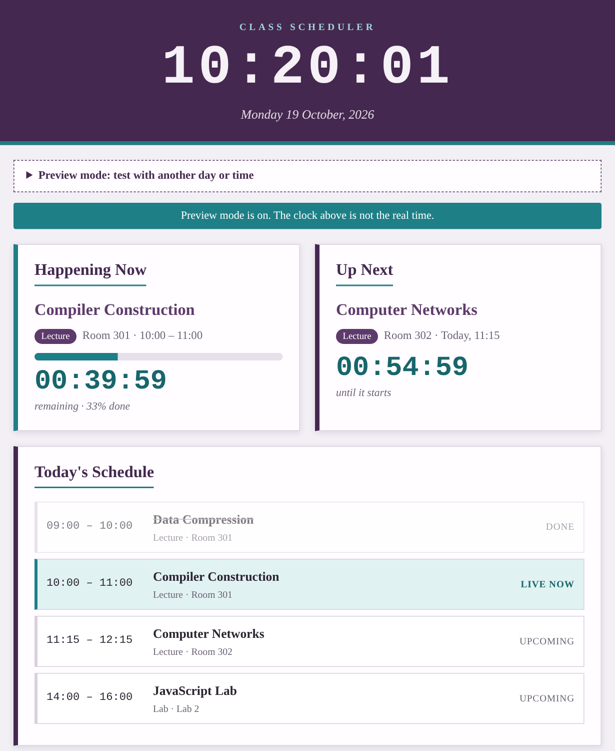  Fig. 1: Desktop view (preview mode, Monday 10:20) | 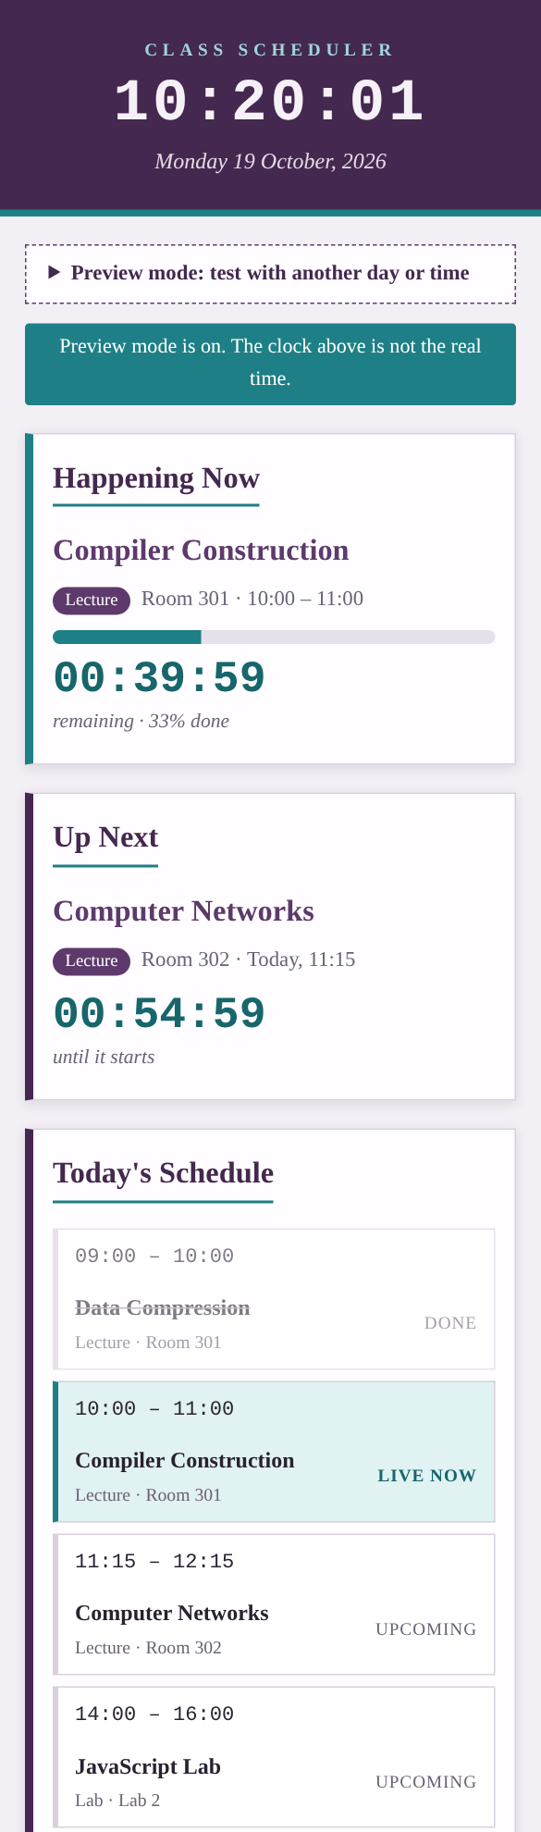  Fig. 2: Phone view (390 px wide)

Test | Observed result
Live clock (setInterval) | Clock changed every second
Countdown at 10:20 Monday | Class ends in 00:40:00; next class in 00:55:00
Alert at 10:00 (setTimeout) | Message shown, then hidden after 5 seconds
Focus timer | 01:00 to 00:58, paused (stayed 00:58), reset to 01:00
Phone width (390 px) | One column, no sideways page scroll
Conclusion
setInterval() kept the clock, countdowns and progress bar up to date every second, while setTimeout() fired a single alert exactly when a class started or ended and then scheduled the next one. Splitting the code into data.js, time.js, scheduler.js and main.js with import and export kept each file short and easy to test. The CSS Grid layout changes to one column on small screens, so the scheduler works on both a laptop and a phone.

